**Gene, Preference and Behavior: Evidence from China**

Yu Qina, Jianqing Ruanb, Ling Wangb, Jubo Yanc

a *Department of Real Estate, National University of Singapore, Singapore*

b *China Academy for Rural Development, Zhejiang University, Hangzhou, China*

c *Division of Economics, Nanyang Technological University, Singapore*

**Abstract**

This research argues that gene differences may shape the large cross-regional variation in preferences and behaviors. We focus on three categories of representative and fundamental preferences as well as related behaviors: risk preference, time preference and social preference. Taking China as an example and using data from China Family Panel Studies (CFPS), we find that genetic distance explains the differences in risk preference, time preference and social preference after controlling for potential confounding factors. Genetic distance also explains differences in related behaviors including differences in entrepreneurship, risk-taking behavior, saving behavior, cooperative behavior and prosocial behavior. In general, genetic distance accounts for 10-23% of a standard deviation of differences in preferences and behaviors. The potential for differences in genetic influence between the sexes have also been explored. We find that genetic effects are not the same for males and females. Our study provides new evidence for the heritability of preferences and behaviors and proposes a new explanation for cross-regional disparities.

*Keywords:* genetic distance; heritability; preference; behavior

JEL Codes: E70; Z00; Z13

Funding: This work was supported by the National Institutes of Health [grant numbers xxxx, yyyy]; the Bill & Melinda Gates Foundation, Seattle, WA [grant number zzzz]; and the United States Institutes of Peace [grant number aaaa].

**1. Introduction**

Researchers have discovered systematic cross-regional differences in many fundamental preferences, such as risk preference Hsee and Weber (1999), trust (Bohnet et al., 2010; Zhang and Ke, 2002) and collectivism-individualism (Talhelm et al., 2014; Van de Vliert et al., 2013). The regional variation in preferences is a major contributor to regional disparities in behaviors as well as economic development. An important question raised by such findings is that how do such differences arise? Are preferences and behaviors inherited? Does genetic variation account for differences in preferences and behaviors? These questions are fundamental for our understanding of individual behavior as well as regional economic development. Nonetheless, existing literature has not offered much systematic evidence on them.

This paper asks whether genetic variation can help explain cross-regional heterogeneity in preference as well as related behaviors. We focus on three categories of preferences as well as related behaviors: risk preference, time preference and social preference , because they are the most representative and fundamental preferences in economics, which have profound effects on economic development. For example, risk preference and individualism predict innovative behaviors, such as entrepreneurship (Hvide and Panos, 2014; Wu and Knott, 2006). Time preference and risk preference affect saving and investment behaviors, which are important determinants of cross-sectional variation in wealth accumulation (Cronqvist and Siegel, 2015; Friedman, 1953).Social preferences like trust and collectivism are highly correlated with cooperative or prosocial behaviors, such as charity donation and social network (Allik and Realo, 2004; Kashif et al., 2015).

The idea that genetic variation accounts for differences in preferences and behaviors has received some support in genetic research. Dreber et al. (2009) and Kuhnen and Chiao (2009) have found that the variants of two genes that regulate dopamine and serotonin neurotransmission (5-HTTLPR and DRD4) are significant determinants of risk-taking behaviors. De Neve and Fowler (2014) showed a specific genotype is associated with real-world behavior, they found that MAOA gene is associated with credit card borrowing behavior. Genetic association studies suggest that some genes of central neurotransmitter systems influence people’s social sensitivity, which reflects the degree of emotional responsivity to social events and experiences (Caspi et al., 2003; Eisenberger et al., 2003; Way et al., 2009). Way and Lieberman (2010) found that the frequency of the social sensitivity alleles (5-HTTLPR, A118G, MAOA-uVNTR) is larger in collectivistic populations than individualistic populations.

Although these literatures have identified some specific genes that determine preferences and behaviors, the debate about whether preferences or behaviors are inherited still rages (Barnea et al., 2010; Cesarini et al., 2009). Moreover, there have yet to be any systematic examinations of the effect of genetic variation on cross-regional differences in preferences and behaviors. In this paper, we study this question by constructing a measure of genetic distance between pairs of cities based on gene frequencies of a unique genetic marker Gm, which is imperfectly correlated with variation in causal variants since Gm is a powerful tool characterizing different populations.

We use China as a test case to examine the effect of genetic distance on differences in preferences and related behaviors. China is a proper case because Chinese population is genetically heterogeneous (Du et al., 1997; Zhao and Lee, 1989). Besides, whereas there is a large variation in genetic distance across cities, the Chinese cities are far more homogeneous in cultural and other aspects, this helps mitigate the confounding influences including religious, linguistic and institutional distance.

We measure a rich set of preferences and behaviors with data from China City Statistical Yearbook and China Family Panel Studies (CFPS). We provide a series of evidence that genetic distance accounts for variation in preferences and behaviors. First, we find that genetic distance is positively correlated with differences in entrepreneurship, saving behavior and individualism among cities in China. Second, to address the problem of migration, we conduct our main analysis with data from CFPS, which can identify local people. We find that genetic distance has a positive and significant effect on differences in risk preference, time preference and social preference (trust and collectivism-individualism) after controlling for potential confounding factors, including geographic distance, difference in culture and environment. Genetic distance explains about 12% of a standard deviation of difference in risk preference, 10.8% of a standard deviation of difference in time preference, and 9%-23% of a standard deviation of difference in social preference. Third, we test the effect of genetic distance on behaviors and find that genetic distance has a positive and significant effect on differences in entrepreneurship, risk-taking behavior, saving behavior, cooperative behavior and prosocial behavior. We find that genetic distance accounts for 9.95% of a standard deviation of difference in entrepreneurship, about 20% of a standard deviation of differences in saving, risk-taking and cooperative behaviors, and 12.84% of a standard deviation of difference in prosocial behavior. We further test whether genetic distance affects behaviors directly or through the channel of preferences, and find that genetic distance’s effects on differences in entrepreneurship and prosocial behavior are due to preference differences. In addition, we provide evidence that genetic distance exerts different influences on preferences and behaviors for each sex: genetic distance explains differences in risk preference, time preference, trust, risk-taking behavior and cooperative behavior in females, but has no effects on males. However, in males, but not females, genetic distance accounts for differences in collectivism, entrepreneurship and pro-social behavior

Our study contributes to the recent literature that relates genetics with economic outcomes. For example, Spolaore and Wacziarg (2009) proposed that genetic distance increases cross-national income difference because genetic distance has a barrier effect on the diffusion of development. Ashraf and Galor (2013) showed that genetic diversity within a society has a hump-shaped effect on development outcomes. Our paper is different from theirs because we argue that gene determines preferences and behaviors rather than genetic distance’s barrier effect. We use a unique genetic marker to calculate the genetic distance that tries to capture the genetic variation of causal genes across regions. In addition, we compare regions within a country, which helps mitigates the confounding influences due to the omission of many variables typical of cross-country comparisons.

Our study is related to the emerging literature that examines the heritability of preferences or behaviors using twin studies. The literature compares monozygotic (MZ) and dizygotic (DZ) twins raised in the same family. They have found that genetic variation explains individual difference in preferences and behaviors, such as risk preference (Cesarini et al., 2009), investor behavior (Barnea et al., 2010; Cesarini et al., 2010) and giving behavior (Cesarini et al., 2009). However, twin studies face the problem of representativeness and reciprocal influences because twins are different from singletons in some traits, and if twins influence each other’s choices positively through social interaction, and MZ twins interact more frequently than DZ twins, then the effect of genetic variation will be somewhat inflated (Constantino and Todd, 2000). Therefore, it is necessary to test the heritability of preference and behavior with a different methodology. Rather than using twin study design, we use genetic distance capturing genetic variation while controlling for potential confounding factors to identify the causal effect of genes.

Our study also contributes to literatures on biological origins of gender difference. While there is a substantial literature on gender differences in preferences (e.g., Andreoni and Vesterlund, 2001; Charness and Gneezy, 2012), there are few studies that empirically examine the potential for differences in genetic influence between the sexes. [Chew et al. (2013)](#_ENREF_15" \o "Chew, 2013 #1921) proposed that sex-hormone genes work differently on ultimatum game between males and female. And the same genes may have difference effects for males and females for extraversion and neuroticism (Eaves et al., 1989) and political preferences (Ebstein et al., 2015; Hatemi et al., 2009). Our paper adds to this strand of works by exploring the differences in genetic effects on risk preference, time preference and social preference as well as related behaviors. As far as we know, we are among the first to test gender difference of genetic influence on risk preference, time preference , social preference and related behaviors.

The rest of this paper is structured as follows; Section 2 explains the definitions and sources of the main variables; Section 3 explains the empirical approach and identification strategy; Section 4 shows the empirical results; Section 5 concludes.

**2. Data and Variables**

*2.1. Genetic distance*

Genetic distance is the degree of genetic differences between a pair of populations (Nei, 1978). It is a measure of variation in gene frequencies among subdivisions (or populations). Suppose that some specific genes determine preferences and behaviors, the allele frequencies of causal genes should be positive or negative correlated with the corresponding preferences and behaviors. And thus the variation in gene frequencies should have a positive effect on absolute differences in corresponding preferences and behaviors. To capture the variation of causal genes determining preferences and behaviors across populations, we use the allele frequencies of Gm haplotype to calculate the genetic distance. The Gm allotypes of human immunoglobulins are inherited differences located on the heavy chains of immunoglobulin G (Callegari‐Jacques et al., 1993). The allotypes are inherited in fixed combinations called Gm haplotypes (Lefranc et al., 1982). Gm haplotype is a unique genetic marker. Vast screenings of populations worldwide, as well as within China, have uncovered considerable variability both in the contents of Gm haplotypes and in their frequencies, which enabled the Gm haplotypes powerful tools for the characterization of different populations (Cavalli-Sforza et al., 1994; Lefranc et al., 1978; Osipova et al., 1999; Zhao and Lee, 1989). Considering Gm system’s unique ability to characterize human populations by specific sets of haplotypes, Gm variation is an indicator of the variation in the whole genetic structure across populations. Gm haplotypes variation is therefore imperfectly correlated with the causal genetic variation between populations. Consequently, the estimated relationship between genetic distance and differences in preferences and behaviors is attenuated, and hence the estimator is a lower bound of the effect.

Genetic distances on the basis of Gm haplotype frequencies were computed using the formula of Nei (1978). Nei’s genetic distance is a widely used measure in genetics. Consider two cities, X and Y. The genetic distance between X and Y is then

$Genetic distance=-ln⁡(J_{XY}/\sqrt{J_{X}*J_{Y}}$) (1)

$J_{X}=\frac{1}{n}\left(\sum_{i=1}^{n}{\sum_{j=1}^{k}{X_{ij}^{2}}}\right)$ (2)

$J_{Y}=\frac{1}{n}\left(\sum_{i=1}^{n}{\sum_{j=1}^{k}{Y_{ij}^{2}}}\right)$ (3)

$J_{XY}=\frac{1}{n}\left(\sum_{i=1}^{n}{\sum_{j=1}^{k}{X_{ij}}}*Y_{ij}\right)$ (4)

where $X_{ij}$ and $Y_{ij}$ are frequencies of the j-th allele at the i-th locus in X and Y, respectively; n is the number of loci; and k is the number of alleles at each locus.

The data on Gm haplotype frequencies of cities in China are obtained from Zhao and Lee (1989). The subjects were drawn from 68 cities. The families of all subjects had resided in the region for at least three generations without mixed marriage with other nationalities. A total of 9,560 subjects were typed for Gm. Summary statistic of genetic distance among cities in China is reported in table 2.

*2.2. Preferences and behaviors*

We measure preferences and behaviors with two different data sources. The first one is China City Statistical Yearbook 2011. We have found three behaviors linked to preferences that we focus on in this database: private sector development, savings rate and divorce rate. Private sector development is a proxy of entrepreneurship. It is defined as the percentage of population employed in private enterprises and self-employed individuals in urban areas. Savings rate is defined as the ratio of savings to disposable income of residents(Zhou, 2014)[1]. Divorce rate is a measure of individualism as it is proved that individualistic regions have higher divorce rates (Lester, 1995). Differences in preferences and behaviors (diff_private_sector, diff_savings_rate, diff_divorce_rate) are calculated as the absolute differences among cities.

A major concern in our research is migration. However, data in the China City Statistical Yearbook 2011 cannot identify local people. We try to mitigate the problem of migration by excluding three major migration-attracting centers in China: Beijing, Shanghai and Guangzhou. After excluding the three cities, we compute differences between all pairs of cities for which data on the corresponding behavior and genetic distance are available, that is 1,225 pairs[2] (based on 50 underlying cities), 1,378 pairs[3] (based on 53 underlying cities) and 2,080 pairs[4] (based on 65 underlying cities) for private sector development, savings rate and divorce rate, respectively. Table 1 presents the summary statistics.

[Insert Table 1 here]

To further address the concern of migration, we use our second data source—CFPS— in our main analysis. CFPS is a large-scale nationally representative survey in China launched in 2010. The CFPS successfully interviewed almost 15,000 families and almost 30,000 individuals within these families in the 2010 baseline survey. The CFPS respondents are tracked through annual follow-up surveys. The survey asks for the birthplace of each respondent, which is used to identify local people in each city. For adults, we only keep the respondents that were born at the survey site. For children, we only keep the respondents that were born at the survey site and whose parents were born at the survey site too.

Another advantage of CFPS is that it has a rich set of questions measuring preferences that we are interested: risk preference, time preference and social preference. According to surveys in CFPS, we can also measure many related behaviors: entrepreneurship, risk-taking behavior, saving behavior, cooperative behavior and prosocial behavior.

*2.2.1. Preference difference:*

*Risk preference differences (diff_risk1; diff_risk2)*. We have two different measures of risk preferences, both are obtained from family questionnaire in CFPS 2014. We match the persons that make decision regarding family’s insurance, savings, and investments to families for these two measures. The first measure of risk preference is created from the question that “*If your family invest, what level of risk are you willing to take*”. We calculate the mean value of risk preference among respondents in each city. diff_risk1 is defined by the absolute difference in the mean values between pairs of cities. The second one is measured by question that “*If your family invest, what kind of risk are you willing to take*”. There are four kinds of responses: “High risk, high return” , “Moderate risk, steady return”，“ Low risk, low return”, “Unwilling to take any investment risk”. Risk preference is measured by the percentage of respondents in each city that had chosen “Unwilling to take any investment risk”. diff_risk2 is the absolute differences among cities.

*diff_time*. Time preference is captured by question from family questionnaire in CFPS 2014: “*I intend to care more about the present and do not consider the future?*” We match the main respondents that completed this questionnaire to families in this question. Time preference is scored from 1 to 5 where 1 means “Totally disagree” and 5 means “Totally agree”. We compute the mean value of the responses. diff_time is defined as absolute differences across cities.

*diff_trust.* Trust is measured by the question from adult questionnaire in CFPS 2014: “*In general, do you think that most people are trustworthy, or it is better to take greater caution when getting along with other people?*” The trust level is defined as the percentage of respondents in each city that had chosen “Most people are trustworthy”. diff_trust is the absolute differences among cities.

*diff_collectivism.* Collectivist attitudes are captured by the question from child questionnaire in CFPS 2014 regarding the extent that the child obeys the rules and the order. Obedience is a measure of collectivism that a higher level of obedience is associated with stronger collectivism (Olsson and Paik, 2016). There are five levels of child’s primary caregiver’ assessment of child’s obedience where 1 means “Totally agree” and 5 means “Totally disagree”. We compute the mean value of each city and then calculate the absolute differences between city pairs.

*dif_individualism.* We measure individualism according to the question from child questionnaire in CFPS 2014 that “*to what extend does the child do his/her work independently?*” The child’s primary caregiver uses this scale (from 1 to 5) where 1 means “Totally agree” and 5 means “Totally disagree” to assess the level of individualism of respondents. We then aggregated responses by city, computing the mean level of the responses. diff_invididualism is defined as absolute differences among cities.

*2.2.2 Behavior difference*

*diff_entrepreneurship*. Entrepreneurship is defined as the percentage of respondents that is self-employed in each city. The information comes from adult questionnaire in CFPS 2010: “*What is the overall type of your current job?*” diff_entrepreneurship is the absolute differences in entrepreneurship among cities.

*diff_savings_rate*. Saving behavior measured by savings rate is defined as 1-living expenditure/total income. The information comes from family questionnaire in CFPS 2014. We match the persons that make decisions regarding family expenditure to families in this question. We compute the mean value of savings rate in each city and then diff_savings_rate is computed as the absolute differences between city pairs.

*diff_alcoholism*. Alcoholism is a widely used measure of risk-taking behavior (Barsky et al., 1997; Dohmen et al., 2011). We measure alcoholism according to the survey question in adult questionnaire in CFPS 2014: “*Did you consume alcohol at least 3 times a week in the past month?*” Alcoholism is defined as the percentage of respondents in each city that had answered “Yes” in this question. diff_alcoholism is defined as the absolute differences in alcoholism among cities.

*diff_neighborhood.* We take neighborhood intimacy as a measure of cooperative behavior, which is captured by the question in the family questionnaire in CFPS 2014 “*In the past 12 months, how was the relationship between your family and neighbors?*” We match the main respondents that completed this questionnaire to families in this question. The neighborhood intimacy is scored from 1 to 5 where 1 means “very strained” and 5 means “very harmonious”. We aggregated responses by city, computing the mean value of the responses in each city. diff_neighborhood is then defined as the absolute differences between pairs of cities.

*diff_donation*. We measure this prosocial behavior by the question in the family questionnaire in CFPS 2010: “*Last year, did your family donate money or material goods to any institution or individual?*” We match the household head to families for this question. We calculate the percentage of respondents in each city that had answered “Yes” in this question, and thus diff_donation is defined as absolute differences between paired cities.

Table 2 reports the summary statistics for differences in preferences and behaviors obtained from CFPS. The number of overlapped cities between CFPS and genetic distance dataset is 34, therefore the number of city pairs is 561[5]. Due to missing data in CFPS, the number of overlapped cities for the two measures of risk preference and time preference is 30, and for savings rate is 33. Therefore, the numbers of city pairs for them are 435 and 528[6], respectively.

[Insert Table 2 here]

**3. Empirical Approach and Identification Strategy**

To examine the effect of genetic distance on preference differences, we employ the following OLS specification:

${diff_preference}_{ij}$ = $β_{0}$ + $β_{1}{genetic_distance}_{ij}$ + $β_{2}^{'}X_{ij}$ + $ε_{ij}$ (5)

where ${diff_preference}_{ij}$ denotes the preference difference between city i and j, ${genetic_distance}_{ij}$ denotes the genetic distance between city i and j, $X_{ij}$ is a set of control variables that measure possible confounding factors, and $ε_{ij}$ is the error term.

The key identification assumption is that genetic distance is an exogenous variable since genetic distance cannot be changed, at least in the short run. A significant threat to identification comes from migration. Genetic distance capture the genetic variation of local people among cities. Migration may change the genetic structure of populations in the city, which cause a measurement error in genetic distance. To address this concern, we use data from CFPS in our main analysis. As discussed in Section 2, CFPS asks for the birthplace of each respondents, which is used to identify the local people for sufficiently long time. We thus are able to measure preferences and behaviors of local people.

Another potential threat to identification comes from some possible confounding factors, we control for the following confounding factors in our research:

*3.1. Culture difference*

Culture difference is a possible confounding factor that may be correlated with both genetic distance and differences in preferences and behaviors. Populations that have experienced more mixing—or populations that have become separated more recently—are closer genetically, and are also more similar in culture (Desmet et al., 2011; Spolaore and Wacziarg, 2009). Therefore, it is necessary to control for culture difference in our analysis.

Our measures of culture difference are geographic distance and dialect distance. Both of them are widely used proxies for culture difference (Desmet et al., 2011; Falck et al., 2012; Fearon, 2003; Spolaore and Wacziarg, 2009). Geographic distance has a barrier effect of culture diffusion; therefore, geographic distance is highly correlated with culture difference. Moreover, geographic distance itself is a confounding factor to our research since genetic distance and geographic distance are likely to be highly correlated. Geographic distance is defined as the great-circle distance between city i and j[7].

Language is a carrier of regional history and culture and it reflects culture transmission between generations. According to Greenberg (1956), the formula of dialect distance between city i and j is as follows:

${Dialect distance}_{ij}$ =1- $\sum_{mn}{(m_{i}n_{j})(r_{MN})}$ (6)

where $r_{MN}$ is the measure of resemblance between dialect M and N. The data on dialect resemblance ($r_{MN}$) in China is derived from Cheng (1991). The author computed Chinese dialect similarity according to initials, finals and tones. $m_{i}$ and $n_{j}$ respectively designate the proportion of M speakers in city i and N speakers in city j to the total population. The dialects of each prefecture in China can be obtained in “Dictionary of Chinese Dialect” (Xu and Ichiro, 1999). Population data are derived from the 2000 Population Census of China.

*3.2. Gene-culture co-evolution*

Culture–gene co-evolutionary theory posits that cultural values have evolved, are adaptive and influence the social and physical environments under which genetic selection operates (Chiao and Blizinsky, 2010). Culture generally evolves more rapidly than genes, creating novel environments that expose genes to new selective pressures (Richerson et al., 2010). For example, Henrich (2004) proposed that cultural group selection may lead to the subsequent spread of prosocial genes. Because cultural group selection spreads punishment, prosocial genes may be favored as they allow individuals avoid the costs of being punished for not cooperating.

“Gene-culture co-evolution” may not be an issue in our research though. We test the effect of genetic distance in the 1980s on contemporary preference, which should not have reverse causality issue. However, Culture–gene co-evolutionary theory also argues that “cultural values have evolved, are adaptive and influence the social and physical environments under which genetic selection operates”. Social environment is already captured by the above mentioned culture difference. As far as we know, there is currently no direct evidence or case proving that physical environments shape preference and gene simultaneously. In case that there is an unknown physical environment that may shape people’s preference and gene at the same time, we will generally control for difference in physical environment.

Our first measure of physical environment difference is climate difference. Climate difference is defined by a dummy variable indicating whether city i and j are in the same climate zone. Our second measure of physical environment is based on Hu Line. It is an imaginary line that divides China into two equal parts with strikingly different characteristics. China’s natural landscape, climate, [topography](javascript:;) and culture splits along the Hu Line. Areas to the west are more mountainous, semiarid and colder while areas to the east are flatter, more humid and warmer. Grazing is more widespread in the west, while farming is more common in the east. Hu Line can generally capture the environment difference as well as culture difference in China. In our analysis, we include a dummy variable indicating whether city i and j are on the same side of Hu Line. Besides, the above mentioned geographic distance can also capture the physical environment difference.

**4. Empirical results**

*4.1. Descriptive analysis*

We start our analysis by presenting the general pattern between genetic distance and differences in preference or behavior. We test the general pattern in a larger sample with data from China City Statistical Yearbook 2011. The observations are divided into 50 percentiles according to genetic distance. For each percentile, we compute the mean value of genetic distance and outcome variables for drawing the scatter plots in figures 1-3. Fig 1 presents the relationship between genetic distance and differences in private sector development among cities. It shows that genetic distance and difference in private sector are positively correlated. Fig 2 also displays a positive relationship between genetic distance and differences in saving behavior. Fig 3 presents the relationship between genetic distance and difference in divorce rate while divorce rate is a measure of individualism (Lester, 1995). The three scatter plots provide preliminary evidence that genetic distance may explain the variation in preferences and behaviors among regions.

[Insert Figure 1 here]

[Insert Figure 2 here]

[Insert Figure 3 here]

*4.2. Genetic distance and preference differences*

Although data from China City Statistical Yearbook 2011 can cover most cities in China, it has limited number of measures of preferences and behaviors. Moreover, it cannot identify the local people. To address this concern, we conduct our main analysis with data from CFPS.

The regression results for the relationships between genetic distance and preference differences are presented in Table 3. The regressions have controlled for geographic distance, dialect distance, climate difference and Hu Line. According to columns1-2 in Table 3, we find that genetic distance has a positive effect on two measures of risk preference differences. And the magnitude of the effect of genetic distance on risk preference is far from trivial. An increase of one standard deviation in genetic distance has the effect of increasing risk preference differences by more than 12% standard deviations. We compare the results to those that have previously reported in the classical twin study on the heritability of risk preference. For example, Cesarini et al. (2009) found that genetic differences explain approximately 20% of risk preference variation. Cesarini et al. (2010) found that approximately 25% of individual variation in risk preference is due to genetic variation. Generally, the estimated magnitudes of genetic distance for risk preference are smaller than those in the twin studies. In making the comparisons, however, it is important to bear in mind that genetic distance is only imperfectly correlated with the differences in causal genes, so the estimator of genetic distance is a lower bound.

Columns 3-6 of Table 3 report the effects of genetic distance on differences in time preference and social preference (trust and collectivism-individualism). We find that genetic distance has a positive and significant effect on differences in trust and collectivism-individualism. Although the estimated effect is attenuated since genetic distance is only imperfectly correlated with variation in causal variants, genetic distance has a strongly positive effect on difference in trust and collectivism (statistically significant at the 1 percent level). One standard deviation in genetic distance between cities accounts for about 20% of a standard deviation of differences in trust and collectivism, which is economically large. We further compare the results with the previous literature: Cesarini et al. (2008) has found that genetic variation accounts for 10-32% of individual differences in the trust game with twin study design, which is similar with the estimated magnitude in our research.

The results suggest that genetic distance has a positive effect on the variation in the three categories of representative and fundamental preferences, including risk preference, time preference and social preference. And the potential confounding factors are unlikely driving the results.

*4.3. Genetic distance and behavior differences*

After examining genetic distance’s effect on preference differences, we further test whether genetic distance affects variation in behaviors, including entrepreneurship, savings rate, risk-taking behavior (alcoholism), cooperative behavior (neighborhood intimacy) and prosocial behavior (donation). We choose theses five behaviors because they are highly related with the three fundamental preferences that we focus on in this paper according to the relevant literature.

The regression results are reported in Table A1. All the regressions have controlled for the potential confounding factors. According to columns 1-3 in Table A1, we draw Fig 4 presenting the effects of genetic distance on differences in three types of behaviors including entrepreneurship, savings rate and alcoholism. The bars show the estimators of genetic distance’s effect while the error bars represent the 95% confidence interval. The results show that we obtain a similar pattern with the results on preference differences: genetic distance has a positive and significant effect on differences in entrepreneurship, savings rate and alcoholism. For instance, one standard deviation in genetic distance accounts for 9.95% of a standard deviation of differences in entrepreneurship. Compared with previous studies, the magnitude is lower than the estimated heritability for entrepreneurship in the twin study, which is about 40% (Nicolaou et al., 2008; Zhang et al., 2009). Spolaore and Wacziarg (2009) explored the relationship between genetic distance and income differences in the cross-country study and found that genetic distance accounts for 16.79% of one standard deviation of income differences. However, the estimated magnitude of genetic distance’s effect in our research is a lower bound.

[Insert Figure 4 here]

Now we turn to examining the effect of genetic distance on differences in cooperative behavior (neighborhood intimacy), and prosocial behavior (charity donation), which generally reflect trust and collectivism. The regression results are reported in column 4-5 in table A1. Fig 5 shows the coefficients and confidence intervals of genetic distance. The results show that genetic distance has a positive and significant effect, suggesting that genetic distance can explain the variation in cooperative behavior and prosocial behavior. More specifically, one standard deviation in genetic distance between cities accounts for 22.70% and 12.84% of a standard deviation of differences in cooperative and prosocial behaviors, respectively. Compared with previous research, Cesarini et al. (2008) found that genetic variation accounts for 10-32% of individual differences in the trust game. They suggested that this provides evidence for heritability of cooperative behavior, but they did not provide further direct evidence for behavior. The results of this paper further supports Cesarini et al. (2008) by testing the effect of gene on cooperative behavior as well as prosocial behavior directly.

[Insert Figure 5 here]

We further explore whether genetic distance affects behavior differences directly or through the channel of preference differences. Table 4 reports the results. The dependent variables are behavior differences. We control for geographic distance, dialect distance, climate difference and Hu Line. In table 4, each behavior has two regression results. In column 1, 3, 5, 7 and 9, we include only genetic distance and the various controls. The results show that genetic distance has a significantly positive effect on the difference in behaviors. We then add related preference differences that affect corresponding behaviors in column 2, 4, 6, 8 and 10 (according to relevant literatures, we add difference in risk preference and individualism for difference in entrepreneurship, add difference in risk preference and time preference for difference in savings rate and alcoholism and add difference in trust and collectivism for difference in neighborhood intimacy and donation behavior). In column 2 and 10, the effect of genetic distance has shrunk with the inclusion of these preference differences. This implies that the genetic distance’ effect on differences in entrepreneurship and donation behavior may be due to preference differences. In column 4, 6 and 8, genetic distance remains highly significant even after controlling for preference differences. This suggests that preference differences cannot account for genetic distance’s effect on these behavior differences, and genetic distance affects difference in savings rate, alcoholism and neighborhood intimacy directly.

*4.4 Gender difference of genetic influence*

To verify whether there is a gender difference in the effect of genetic distance, we regress difference in preferences and behaviors of males and females on genetic distance separately[8]. All the regressions have controlled for geographic distance, dialect distance, Hu Line and climate difference. Figure 6-9 below present the regression results. The figures report coefficients on genetic distance and 95% confidence intervals (The detailed regression results are reported in table A2 and table A3). The grey bars represent the coefficients on genetic distance of males while the black bars represent results of females.

According to figure 6-9, we find that the effect of genetic distance differed between males and females for most of preferences and behaviors, providing strong evidence that there is a gender difference of genetic influence. More specifically, genetic distance has a significantly positive effect on difference in risk preference, time preference, trust, savings rate, alcoholism in females while has no effect in males. And genetic distance accounts for difference in collectivism, entrepreneurship and donation behavior in males, but has no effect in females. Our results imply that genes matter and they matter differently for each sex, which are consistent with previous studies. For instance, Hatemi et al. (2009) found that the same genes influence males and females differently for many political preferences. Ebstein et al. (2015) proposed that the effect of DRD4 gene variants on political attitude is highly significant for females, but not for males.

[Insert Figure 6 here]

[Insert Figure 7 here]

[Insert Figure 8 here]

[Insert Figure 9 here]

**5. Conclusions**

In this paper, we examine the effect of gene distance on large cross-regional variation in preferences and behaviors. We have focused on three preferences as well as related behaviors: risk preference, time preference and social preference (trust and collectivism-individualism). Taking China as an example, we find that genetic variation accounts for differences in preferences after controlling for potential confounding factors. Genetic distance also explains differences in entrepreneurship, risk-taking behavior, saving behavior, cooperative behavior and prosocial behavior. Generally, genetic distance accounts for 10-23% of a standard deviation of differences in preferences and behaviors. We also find that the effects of genetic distance differ between males and females.

Our results provide a new explanation for origins of cross-regional disparities in preferences and behaviors. The considerations on genetic influences have remained relatively absent in the existing literature. We argue that genetic variation is an important source of variation in preferences and behaviors. We find that genetic distance capturing variation in potential causal variants explains cross-regional variation in preferences and behaviors, suggesting that differences in genes account for regional variation. We hope that the results will lead to a better understanding of comparative economic development ultimately. Our results also add to the debate on the heritability of preferences and behaviors. We confirm the view that preferences and behaviors are, at least partially, inherited. Finally, our results lead to a deeper understanding of gender difference in preferences and behaviors.

Our results suggest a number of directions for future research. First, it would be useful to identify the causal genes of preferences and behaviors. In fact, there are already some papers that have uncovered some specific genes determining preferences and behaviors (Dreber et al., 2009; Kuhnen and Chiao, 2009).Second, our results shed some light on policy making. If genes determine preferences and behaviors, policy makers may use such information to make better policies in different regions. For example, the policies that aim to help people to live a healthier life would need to consider time preference and risk preference. Third, the future research also needs to investigate genetic systems that act differently in males and females for a host of preferences and behaviors.

**References:**

Allik, J., Realo, A., 2004. Individualism-collectivism and social capital. Journal of Cross-Cultural Psychology 35(1), 29-49.

Andreoni, J., Vesterlund, L., 2001. Which is the fair sex? Gender differences in altruism. The Quarterly Journal of Economics 116(1), 293-312.

Ashraf, Q., Galor, O., 2013. The'Out of Africa'hypothesis, human genetic diversity, and comparative economic development. American Economic Review 103(1), 1-46.

Barnea, A., Cronqvist, H., Siegel, S., 2010. Nature or nurture: What determines investor behavior? Journal of Financial Economics 98(3), 583-604.

Barsky, R.B., Juster, F.T., Kimball, M.S., Shapiro, M.D., 1997. Preference parameters and behavioral heterogeneity: An experimental approach in the health and retirement study. The Quarterly Journal of Economics 112(2), 537-579.

Bohnet, I., Herrmann, B., Zeckhauser, R., 2010. Trust and the reference points for trustworthiness in Gulf and Western countries. The Quarterly Journal of Economics 125(2), 811-828.

Callegari‐Jacques, S.M., Salzano, F.M., Constans, J., Maurieres, P., 1993. Gm haplotype distribution in Amerindians: Relationship with geography and language. American Journal of Physical Anthropology 90(4), 427-444.

Caspi, A., Sugden, K., Moffitt, T.E., Taylor, A., Craig, I.W., Harrington, H., McClay, J., Mill, J., Martin, J., Braithwaite, A., 2003. Influence of life stress on depression: moderation by a polymorphism in the 5-HTT gene. Science 301(5631), 386-389.

Cavalli-Sforza, L.L., Menozzi, P., Cavalli-Sforza, L., Cavalli-Sforza, L., Piazza, A., 1994, The history and geography of human genes. Princeton university press.

Cesarini, D., Dawes, C.T., Fowler, J.H., Johannesson, M., Lichtenstein, P., Wallace, B., 2008. Heritability of cooperative behavior in the trust game. Proceedings of the National Academy of Sciences 105(10), 3721-3726.

Cesarini, D., Dawes, C.T., Johannesson, M., Lichtenstein, P., Wallace, B., 2009. Genetic Variation in Preferences for Giving and Risk Taking. Quarterly Journal of Economics 124(2), 809-842.

Cesarini, D., Johannesson, M., Lichtenstein, P., Sandewall, O., Wallace, B., 2010. Genetic Variation in Financial Decision-Making. Journal of Finance 65(5), 1725-1754.

Charness, G., Gneezy, U., 2012. Strong evidence for gender differences in risk taking. Journal of Economic Behavior & Organization 83(1), 50-58.

Cheng, C.-C., 1991. Quantifying affinity among Chinese dialects. Journal of Chinese Linguistics Monograph Series(3), 76-110.

Chew, S.H., Ebstein, R.P., Zhong, S., 2013. Sex-hormone genes and gender difference in ultimatum game: Experimental evidence from China and Israel. Journal of Economic Behavior & Organization 90, 28-42.

Chiao, J.Y., Blizinsky, K.D., 2010. Culture–gene coevolution of individualism–collectivism and the serotonin transporter gene. Proceedings of the Royal Society of London B: Biological Sciences 277(1681), 529-537.

Constantino, J.N., Todd, R.D., 2000. Genetic structure of reciprocal social behavior. American Journal of Psychiatry 157(12), 2043-2045.

Cronqvist, H., Siegel, S., 2015. The origins of savings behavior. Journal of political Economy 123(1), 123-169.

De Neve, J.-E., Fowler, J.H., 2014. Credit card borrowing and the monoamine oxidase A (MAOA) gene. Journal of Economic Behavior & Organization 107, 428-439.

Desmet, K., Le Breton, M., Ortuño-Ortín, I., Weber, S., 2011. The stability and breakup of nations: a quantitative analysis. Journal of Economic Growth 16(3), 183.

Dohmen, T., Falk, A., Huffman, D., Sunde, U., Schupp, J., Wagner, G.G., 2011. Individual risk attitudes: Measurement, determinants, and behavioral consequences. Journal of the European Economic Association 9(3), 522-550.

Dreber, A., Apicella, C.L., Eisenberg, D.T., Garcia, J.R., Zamore, R.S., Lum, J.K., Campbell, B., 2009. The 7R polymorphism in the dopamine receptor D4 gene (DRD4) is associated with financial risk taking in men. Evolution and Human Behavior 30(2), 85-92.

Du, R., Xiao, C., Cavalli-Sforza, L., 1997. Genetic distances between Chinese populations calculated on gene frequencies of 38 loci. Science in China Series C: Life Sciences 40(6), 613-621.

Eaves, L.J., Eysenck, H.J., Martin, N.G., 1989, Genes, culture and personality: An empirical approach. Academic Press.

Ebstein, R.P., Monakhov, M.V., Lu, Y., Jiang, Y., Lai, P.S., Chew, S.H., 2015. Association between the dopamine D4 receptor gene exon III variable number of tandem repeats and political attitudes in female Han Chinese. Proc Biol Sci 282(1813), 20151360.

Eisenberger, N.I., Lieberman, M.D., Williams, K.D., 2003. Does rejection hurt? An fMRI study of social exclusion. Science 302(5643), 290-292.

Falck, O., Heblich, S., Lameli, A., Südekum, J., 2012. Dialects, cultural identity, and economic exchange. Journal of urban economics 72(2-3), 225-239.

Fearon, J.D., 2003. Ethnic and cultural diversity by country. Journal of Economic Growth 8(2), 195-222.

Friedman, M., 1953. Choice, chance, and the personal distribution of income. Journal of political Economy 61(4), 277-290.

Greenberg, J.H., 1956. The measurement of linguistic diversity. Language 32(1), 109-115.

Hatemi, P.K., Medland, S.E., Eaves, L.J., 2009. Do Genes Contribute to the "Gender Gap"? Journal of Politics 71(1), 262-276.

Henrich, J., 2004. Cultural group selection, coevolutionary processes and large-scale cooperation. Journal of Economic Behavior & Organization 53(1), 3-35.

Hsee, C.K., Weber, E.U., 1999. Cross‐national differences in risk preference and lay predictions. Journal of Behavioral Decision Making 12(2), 165-179.

Hvide, H.K., Panos, G.A., 2014. Risk tolerance and entrepreneurship. Journal of Financial Economics 111(1), 200-223.

Kashif, M., Sarifuddin, S., Hassan, A., 2015. Charity donation: intentions and behaviour. Marketing Intelligence & Planning 33(1), 90-102.

Kuhnen, C.M., Chiao, J.Y., 2009. Genetic determinants of financial risk taking. PloS one 4(2), e4362.

Lefranc, G., Lefranc, M.P., Helal, A., Boukef, K., Chaabani, H., Gandoura, M.S., Loghem, E.v., 1982. Unusual heavy chains of human IgG immunoglobulins: rearrangements of the CH domain exons. International Journal of Immunogenetics 9(1), 1-9.

Lefranc, G., Rivat, L., Serre, J.-L., Lalouel, J.-M., Pison, G., Loiselet, J., Ropartz, C., de Lange, G., van Loghem, E., 1978. Common and uncommon immunoglobulin haplotypes among Lebanese communities. Human genetics 41(2), 197-209.

Lester, D., 1995. Individualism and divorce. Psychological Reports 76(1), 258-258.

Nei, M., 1978. The theory of genetic distance and evolution of human races. Japanese Journal of Human Genetics 23(4), 341-369.

Nicolaou, N., Shane, S., Cherkas, L., Hunkin, J., Spector, T.D., 2008. Is the tendency to engage in entrepreneurship genetic? Management Science 54(1), 167-179.

Olsson, O., Paik, C., 2016. Long-run cultural divergence: Evidence from the neolithic revolution. Journal of Development Economics 122, 197-213.

Osipova, L.P., Posukh, O.L., Wiebe, V.P., Miyazaki, T., Matsumoto, H., Lefranc, G., Lefranc, M.-P., 1999. BamHI-SacI RFLP and Gm analysis of the immunoglobulin IGHG genes in the Northern Selkups (west Siberia): new haplotypes with deletion, duplication and triplication. Human genetics 105(6), 530-541.

Richerson, P.J., Boyd, R., Henrich, J., 2010. Gene-culture coevolution in the age of genomics. Proceedings of the National Academy of Sciences 107(Supplement 2), 8985-8992.

Spolaore, E., Wacziarg, R., 2009. The diffusion of development. The Quarterly Journal of Economics 124(2), 469-529.

Talhelm, T., Zhang, X., Oishi, S., Shimin, C., Duan, D., Lan, X., Kitayama, S., 2014. Large-scale psychological differences within China explained by rice versus wheat agriculture. Science 344(6184), 603-608.

Van de Vliert, E., Yang, H., Wang, Y., Ren, X.-p., 2013. Climato-economic imprints on Chinese collectivism. Journal of Cross-Cultural Psychology 44(4), 589-605.

Way, B.M., Lieberman, M.D., 2010. Is there a genetic contribution to cultural differences? Collectivism, individualism and genetic markers of social sensitivity. Social cognitive and affective neuroscience 5(2-3), 203-211.

Way, B.M., Taylor, S.E., Eisenberger, N.I., 2009. Variation in the μ-opioid receptor gene (OPRM1) is associated with dispositional and neural sensitivity to social rejection. Proceedings of the National Academy of Sciences 106(35), 15079-15084.

Wu, B., Knott, A.M., 2006. Entrepreneurial risk and market entry. Management Science 52(9), 1315-1330.

Xu, B.H., Ichiro, M., 1999, Dictionary of Chinese Dialect. Zhonghua Book Company, Shanghai.

Zhang, W., Ke, R., 2002. Trust in China: A Cross-Regional Analysis [J]. Economic Research Journal 10, 59-70.

Zhang, Z., Zyphur, M.J., Narayanan, J., Arvey, R.D., Chaturvedi, S., Avolio, B.J., Lichtenstein, P., Larsson, G., 2009. The genetic basis of entrepreneurship: Effects of gender and personality. Organizational Behavior and Human Decision Processes 110(2), 93-107.

Zhao, T., Lee, T.D., 1989. Gm and Km allotypes in 74 Chinese populations: a hypothesis of the origin of the Chinese nation. Human genetics 83(2), 101-110.

Zhou, W., 2014. Brothers, household financial markets and savings rate in China. Journal of Development Economics 111, 34-47.

Fig.1. The general pattern between genetic distance and difference in private sector development among cities in China

C:\1-学术\NUS-科研\1gene&preference\进展\Slides\作图\企业家精神.tif

Notes: The scatter plot is generated by plotting values of genetic distance and difference in private sector development across cities. The data source is China City Statistical Yearbook 2011.

Fig. 2. The general pattern between genetic distance and difference in saving behavior among cities in China

C:\1-学术\NUS-科研\1gene&preference\进展\motivation\美颜过的图\储蓄率修正后.tif

Notes: The scatter plot is generated by plotting values of genetic distance and difference in saving behavior across cities. The data source is China City Statistical Yearbook 2011.

Fig. 3. The general pattern between genetic distance and difference in divorce rate (individualism) among cities in China

C:\1-学术\NUS-科研\1gene&preference\进展\motivation\美颜过的图\离婚率.tif

Notes: The scatter plot is generated by plotting values of genetic distance and difference in divorce rate (individualism) across cities. The data source is China City Statistical Yearbook 2011.

Fig. 4. The effect of genetic distance on differences in entrepreneurship, savings rate and alcoholism

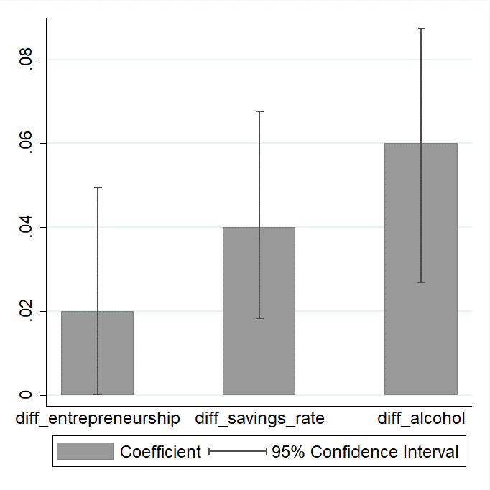

Notes: We regress differences in entrepreneurship, savings rate and alcoholism on genetic distance. All the regressions have controlled for geographic distance, dialect distance, Hu Line and climate difference. The coefficients on genetic distance are presented along with 95% confidence intervals. The data source is China Family Panel Studies (CFPS).

Fig. 5. The effect of genetic distance on differences in cooperative behavior (neighborhood) and prosocial behavior (donation)

C:\1-学术\NUS-科研\1gene&preference\进展\!码字\图形打磨\behavior2.tif

Notes: We regress differences in cooperative behavior (neighborhood) and prosocial behavior (donation) on genetic distance. All the regressions have controlled for geographic distance, dialect distance, Hu Line and climate difference. The coefficients on genetic distance are presented along with 95% confidence intervals. The data source is China Family Panel Studies (CFPS).

Fig. 6. The effect of genetic distance on differences in risk preference and time preference among males and females

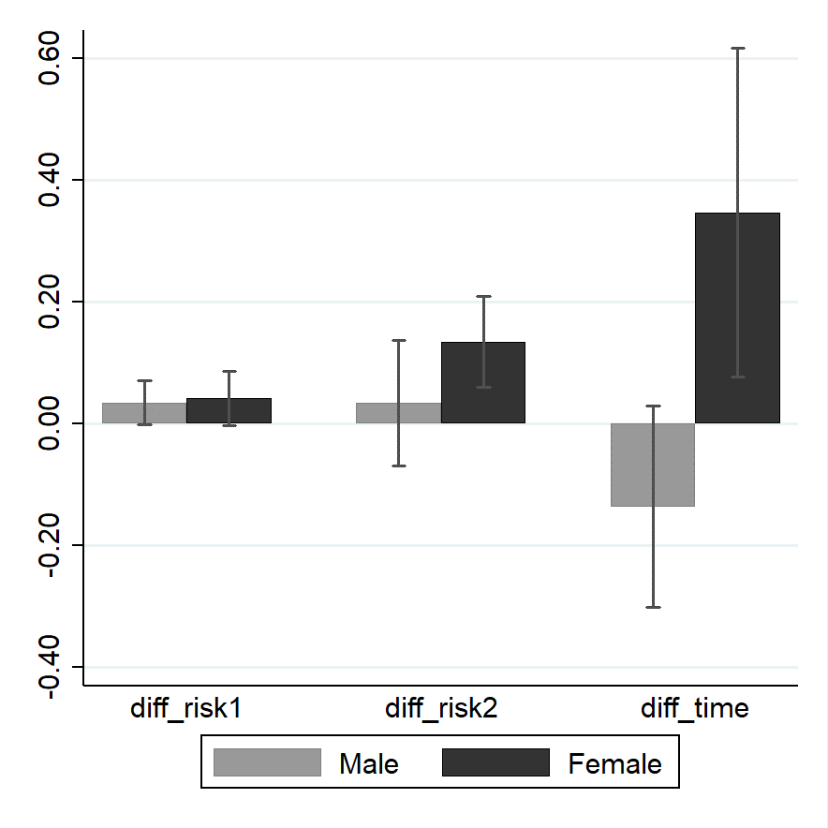

Notes: We regress differences in risk preference and time preference on genetic distance among males and females separately. All the regressions have controlled for geographic distance, dialect distance, Hu Line and climate difference. The coefficients on genetic distance are presented along with 95% confidence intervals. The data source is China Family Panel Studies (CFPS).

Fig. 7. The effect of genetic distance on differences in social preference (trust and collectivism-individualism) among males and females

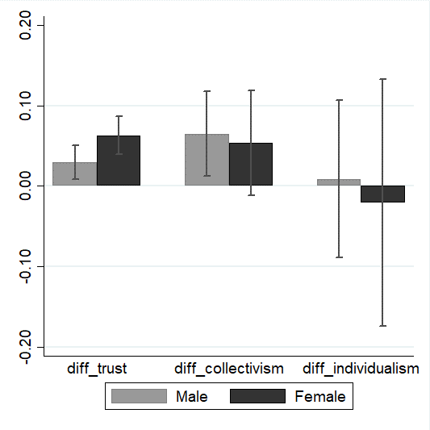

Notes: We regress differences in social preference (trust and collectivism-individualism) on genetic distance among males and females separately. All the regressions have controlled for geographic distance, dialect distance, Hu Line and climate difference. The coefficients on genetic distance are presented along with 95% confidence intervals. The data source is China Family Panel Studies (CFPS).

Fig. 8. The effect of genetic distance on differences in entrepreneurship, savings rate, alcoholism among males and females

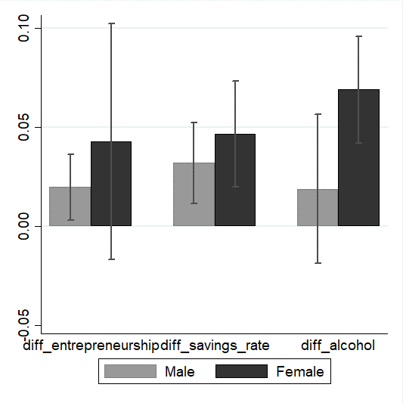

Notes: We regress differences in entrepreneurship, savings rate and alcoholism on genetic distance among males and females separately. All the regressions have controlled for geographic distance, dialect distance, Hu Line and climate difference. The coefficients on genetic distance are presented along with 95% confidence intervals. The data source is China Family Panel Studies (CFPS).

Fig. 9. The effect of genetic distance on differences in cooperative behavior (neighborhood) and prosocial behavior (donation) among males and females

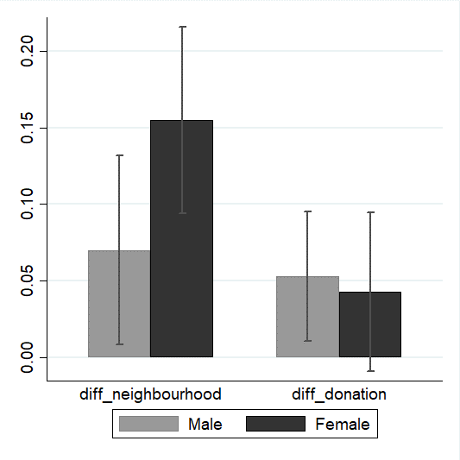

Notes: We regress differences in cooperative behavior (neighborhood) and prosocial behavior (donation) on genetic distance among males and females separately. All the regressions have controlled for geographic distance, dialect distance, Hu Line and climate difference. The coefficients on genetic distance are presented along with 95% confidence intervals. The data source is China Family Panel Studies (CFPS).

Table 1. Summary statistics (data source: China City Statistical Yearbook 2011)

|  |  |  |  |  |  |
| --- | --- | --- | --- | --- | --- |
| Variable | N | mean | sd | min | max |
| diff_private_sector | 1,225 | 0.132 | 0.117 | 0.000 | 0.589 |
| diff_savings_rate | 1,378 | 0.116 | 0.096 | 0.000 | 0.53 |
| diff_divorce_rate | 2,080 | 0.001 | 0.001 | 0.000 | 0.004 |

Notes: Refer to the text for variable definition

Table 2. Summary statistics (data source: China Family Panel Studies)

|  |  |  |  |  |  |  |
| --- | --- | --- | --- | --- | --- | --- |
| Category | Variable | N | mean | sd | min | max |
| Genetic distance | genetic distance | 2,278 | 0.23 | 0.28 | 0.00 | 1.94 |
| Preference | diff_risk1 | 435 | 0.10 | 0.08 | 0.00 | 0.34 |
| diff_risk2 | 435 | 0.27 | 0.22 | 0.00 | 1.00 |
| diff_time | 435 | 0.64 | 0.60 | 0.00 | 3.5 |
| diff_trust | 561 | 0.08 | 0.06 | 0.00 | 0.34 |
| diff_collectivism | 561 | 0.16 | 0.12 | 0.00 | 0.66 |
|  | diff_individualism | 561 | 0.29 | 0.23 | 0.00 | 1.31 |
| Behavior | diff_entrepreneurship | 561 | 0.07 | 0.07 | 0.00 | 0.38 |
| diff_savings_rate | 528 | 0.05 | 0.06 | 0.00 | 0.31 |
| diff_alcohol | 561 | 0.10 | 0.08 | 0.00 | 0.41 |
| diff_neighborhood | 561 | 0.20 | 0.15 | 0.00 | 0.77 |
| diff_donation | 561 | 0.18 | 0.13 | 0.00 | 0.66 |

Notes: Refer to the text for variable definition

Table 3. The effect of genetic distance on economic preference difference

|  |  |  |  |  |  |  |
| --- | --- | --- | --- | --- | --- | --- |
|  | (1) | (2) | (3) | (4) | (5) | (6) |
| Variables | diff_risk1 | diff_risk2 | diff_time | diff_trust | diff_  collectivism | diff_  individualism |
| genetic distance | 0.03** | 0.09** | 0.23* | 0.05*** | 0.08*** | 0.08* |
|  | (1.46) | (0.04) | (0.13) | (0.01) | (0.02) | (0.04) |
| geographic distance | -0.00** | -0.00 | -0.00 | 0.00 | 0.00*** | 0.00*** |
|  | (0.00) | (0.00) | (0.00) | (0.00) | (0.00) | (0.00) |
| dialect distance | -1.16 | 0.03 | -0.03 | 0.00 | 0.08*** | 0.03 |
|  | (2.05) | (0.06) | (0.14) | (0.01) | (0.03) | (0.05) |
| Hu Line | -0.47 | 0.00 | -0.12** | -0.00 | 0.01 | 0.03 |
|  | (0.79) | (0.02) | (0.06) | (0.01) | (0.01) | (0.02) |
| climate | -0.08 | 0.02 | -0.18*** | -0.03*** | -0.05*** | -0.04* |
|  | (0.78) | (0.02) | (0.07) | (0.01) | (0.01) | (0.02) |
| Constant | 11.04*** | 0.24*** | 0.75*** | 0.08*** | 0.12*** | 0.19*** |
|  | (0.87) | (0.02) | (0.07) | (0.01) | (0.01) | (0.02) |
| Observations | 435 | 435 | 435 | 561 | 561 | 561 |
| Standardized beta(%) | 12.59 | 12.31 | 10.8 | 22.69 | 18.87 | 9.18 |
| R-squared | 0.021 | 0.020 | 0.033 | 0.060 | 0.087 | 0.084 |

Notes: Coefficients are reported. Robust standard errors in parentheses. *, ** and *** denote significance at the 10 percent, 5 percent, and 1 percent level, respectively. The data source is China Family Panel Studies (CFPS)

Table 4. The effect of genetic distance on behavior difference: the preference channel

|  |  |  |  |  |  |  |  |  |  |  |
| --- | --- | --- | --- | --- | --- | --- | --- | --- | --- | --- |
|  | (1) | (2) | (3) | (4) | (5) | (6) | (7) | (8) | (9) | (10) |
| Variables | diff_entrepreneurship | | diff_savings_rate | | diff_alcohol | | diff_neighborhood | | diff_donation | |
| genetic distance | 0.02** | 0.01 | 0.04*** | 0.04** | 0.06*** | 0.05*** | 0.12*** | 0.11*** | 0.06*** | 0.02 |
|  | (0.01) | (0.01) | (0.01) | (0.01) | (0.02) | (0.01) | (0.03) | (0.03) | (0.02) | (0.02) |
| diff_risk1 |  | -0.02 |  | 0.25*** |  | 0.10* |  |  |  |  |
|  |  | (0.00) |  | (0.00) |  | (0.00) |  |  |  |  |
| diff_time |  |  |  | -0.01 |  | 0.04*** |  |  |  |  |
|  |  |  |  | (0.00) |  | (0.01) |  |  |  |  |
| diff_trust |  |  |  |  |  |  |  | 0.23** |  | 0.56*** |
|  |  |  |  |  |  |  |  | (0.10) |  | (0.10) |
| diff_collectivism |  |  |  |  |  |  |  | -0.05 |  | 0.14*** |
|  |  |  |  |  |  |  |  | (0.05) |  | (0.05) |
| diff_individualism |  | 0.02** |  |  |  |  |  |  |  |  |
|  |  | (0.01) |  |  |  |  |  |  |  |  |
| Constant | 0.07*** | 0.05*** | 0.05*** | 0.03*** | 0.10*** | 0.05*** | 0.16*** | 0.15*** | 0.13*** | 0.07*** |
|  | (0.01) | (0.01) | (0.01) | (0.01) | (0.01) | (0.01) | (0.01) | (0.02) | (0.01) | (0.01) |
| Observations | 561 | 435 | 528 | 406 | 561 | 435 | 561 | 561 | 561 | 561 |
| Standardized  beta(%) | 9.95 | 7.88 | 19.76 | 16.31 | 20.06 | 17.41 | 22.7 | 21.23 | 12.84 | 4.32 |
| R-squared | 0.016 | 0.055 | 0.036 | 0.123 | 0.053 | 0.203 | 0.057 | 0.069 | 0.113 | 0.188 |

Notes: Coefficients are reported. Robust standard errors in parentheses. *, ** and *** denote significance at the 10 percent, 5 percent, and 1 percent level, respectively. All the regressions have controlled for geographic distance, dialect distance, climate difference and Hu Line (but not presented in this table due to space limitation). The data source is China Family Panel Studies (CFPS).

Table A1. The effect of genetic distance on behavior difference

|  |  |  |  |  |  |
| --- | --- | --- | --- | --- | --- |
|  | (1) | (2) | (3) | (4) | (5) |
| Variables | diff_  entrepreneurship | diff_  savings_rate | diff_alcohol | diff_  neighborhood | diff_donation |
| genetic distance | 0.02** | 0.04*** | 0.06*** | 0.12*** | 0.06*** |
|  | (0.01) | (0.01) | (0.02) | (0.03) | (0.02) |
| geographic distance | 0.00 | -0.00 | -0.00*** | 0.00 | 0.00 |
|  | (0.00) | (0.00) | (0.00) | (0.00) | (0.00) |
| dialect distance | 0.00 | -0.01 | -0.02 | 0.02 | 0.18*** |
|  | (0.02) | (0.01) | (0.02) | (0.04) | (0.03) |
| Hu Line | -0.01** | 0.01 | 0.02*** | 0.02 | 0.05*** |
|  | (0.01) | (0.01) | (0.01) | (0.01) | (0.01) |
| climate | -0.00 | -0.01 | -0.00 | -0.01 | -0.05*** |
|  | (0.01) | (0.01) | (0.01) | (0.01) | (0.01) |
| Constant | 0.07*** | 0.05*** | 0.10*** | 0.16*** | 0.13*** |
|  | (0.01) | (0.01) | (0.01) | (0.01) | (0.01) |
| Observations | 561 | 528 | 561 | 561 | 561 |
| Standardized beta(%) | 9.95 | 19.76 | 20.06 | 22.70 | 12.84 |
| R-squared | 0.016 | 0.036 | 0.053 | 0.057 | 0.113 |

Notes: Coefficients are reported. Robust standard errors in parentheses. *, ** and *** denote significance at the 10 percent, 5 percent, and 1 percent level, respectively. The data source is China Family Panel Studies (CFPS)

Table A2. The effect of genetic distance on preference difference: gender difference

|  |  |  |  |  |  |  |  |  |  |  |  |  |
| --- | --- | --- | --- | --- | --- | --- | --- | --- | --- | --- | --- | --- |
|  | (1) | (2) | (3) | (4) | (5) | (6) | (7) | (8) | (9) | (10) | (11) | (12) |
| Variables | diff_risk1 | | diff_risk2 | | diff_time | | diff_trust | | diff_  collectivism | | diff_  individualism | |
|  | male | female | male | female | male | female | male | female | male | female | male | female |
| genetic distance | 0.03* | 0.04* | 0.03 | 0.13*** | -0.14 | 0.35** | 0.03*** | 0.06*** | 0.07** | 0.05 | 0.01 | -0.02 |
|  | (1.83) | (2.29) | (0.05) | (0.04) | (0.08) | (0.14) | (0.01) | (0.01) | (0.03) | (0.03) | (0.05) | (0.08) |
| geographic distance | -0.00 | -0.00 | -0.00 | 0.00** | 0.00 | -0.00 | 0.00 | -0.00 | 0.00** | 0.00** | 0.00*** | 0.00*** |
|  | (0.00) | (0.00) | (0.00) | (0.00) | (0.00) | (0.00) | (0.00) | (0.00) | (0.00) | (0.00) | (0.00) | (0.00) |
| dialect distance | -5.05* | 1.89 | 0.10 | -0.05 | -0.08 | -0.23 | -0.00 | 0.06*** | 0.04 | 0.32*** | -0.03 | 0.50*** |
|  | (2.66) | (2.90) | (0.07) | (0.06) | (0.12) | (0.16) | (0.01) | (0.02) | (0.03) | (0.06) | (0.06) | (0.13) |
| Hu Line | 3.96*** | -1.77 | -0.04 | -0.02 | -0.11** | -0.03 | -0.00 | 0.00 | -0.03** | 0.10*** | 0.06** | 0.06 |
|  | (1.20) | (1.13) | (0.03) | (0.02) | (0.05) | (0.06) | (0.01) | (0.01) | (0.01) | (0.02) | (0.03) | (0.04) |
| climate | -3.23*** | -2.43** | 0.01 | -0.07*** | -0.02 | -0.23*** | -0.02*** | -0.03*** | -0.04*** | -0.03 | -0.05** | -0.08* |
|  | (1.15) | (1.11) | (0.03) | (0.02) | (0.06) | (0.07) | (0.01) | (0.01) | (0.01) | (0.02) | (0.03) | (0.05) |
| Constant | 14.55*** | 10.71*** | 0.33*** | 0.21*** | 0.66*** | 0.88*** | 0.09*** | 0.08*** | 0.18*** | 0.07*** | 0.33*** | 0.29*** |
|  | (1.18) | (1.28) | (0.03) | (0.03) | (0.05) | (0.08) | (0.01) | (0.01) | (0.01) | (0.02) | (0.03) | (0.04) |
| Observations | 435 | 253 | 435 | 276 | 351 | 325 | 561 | 561 | 561 | 561 | 561 | 528 |
| Standardized  beta (%) | 9.84 | 13.95 | 3.79 | 23.59 | -8.11 | 17.49 | 12.1 | 23.82 | 12.04 | 7.42 | 0.88 | -1.26 |
| R-squared | 0.051 | 0.041 | 0.015 | 0.084 | 0.026 | 0.053 | 0.024 | 0.080 | 0.032 | 0.166 | 0.038 | 0.046 |

Notes: Coefficients are reported. Robust standard errors in parentheses. *, ** and *** denote significance at the 10 percent, 5 percent, and 1 percent level, respectively. The data source is China Family Panel Studies (CFPS).

Table A3. The effect of genetic distance on behavior difference: gender difference

|  |  |  |  |  |  |  |  |  |  |  |
| --- | --- | --- | --- | --- | --- | --- | --- | --- | --- | --- |
|  | (1) | (2) | (3) | (4) | (5) | (6) | (7) | (8) | (9) | (10) |
| Variables | diff_entrepreneurship | | diff_savings_rate | | diff_alcohol | | diff_neighborhood | | diff_donation | |
|  | male | female | male | female | male | female | male | female | male | female |
| genetic distance | 0.02** | 0.04 | 0.03*** | 0.05*** | 0.02 | 0.07*** | 0.07** | 0.15*** | 0.05** | 0.04 |
|  | (0.01) | (0.03) | (0.01) | (0.01) | (0.02) | (0.01) | (0.03) | (0.03) | (0.02) | (0.03) |
| geographic distance | 0.00 | -0.00 | -0.00 | -0.00 | -0.00* | -0.00*** | 0.00 | -0.00* | -0.00 | 0.00 |
|  | (0.00) | (0.00) | (0.00) | (0.00) | (0.00) | (0.00) | (0.00) | (0.00) | (0.00) | (0.00) |
| dialect distance | 0.04*** | -0.08** | -0.02* | -0.04*** | -0.01 | -0.01 | 0.01 | -0.01 | 0.22*** | 0.00 |
|  | (0.01) | (0.04) | (0.01) | (0.01) | (0.02) | (0.01) | (0.04) | (0.04) | (0.03) | (0.03) |
| Hu Line | -0.00 | -0.03** | 0.00 | -0.01* | 0.04*** | -0.01* | 0.01 | 0.01 | 0.06*** | -0.01 |
|  | (0.00) | (0.01) | (0.00) | (0.01) | (0.01) | (0.01) | (0.02) | (0.01) | (0.01) | (0.01) |
| climate | -0.01** | 0.01 | -0.01 | -0.01 | 0.01 | -0.01 | -0.02 | -0.01 | -0.04*** | -0.03* |
|  | (0.00) | (0.01) | (0.01) | (0.01) | (0.01) | (0.01) | (0.02) | (0.01) | (0.01) | (0.01) |
| Constant | 0.06*** | 0.11*** | 0.05*** | 0.06*** | 0.14*** | 0.06*** | 0.21*** | 0.20*** | 0.14*** | 0.20*** |
|  | (0.00) | (0.02) | (0.01) | (0.01) | (0.01) | (0.01) | (0.02) | (0.02) | (0.01) | (0.02) |
| Observations | 561 | 561 | 561 | 561 | 561 | 561 | 561 | 561 | 561 | 561 |
| Standardized  beta (%) | 11.16 | 6.95 | 16.8 | 20.02 | 4.93 | 30.78 | 10.68 | 27.14 | 9.67 | 8.00 |
| R-squared | 0.038 | 0.019 | 0.028 | 0.052 | 0.044 | 0.091 | 0.016 | 0.068 | 0.118 | 0.011 |

Notes: Coefficients are reported. Robust standard errors in parentheses. *, ** and *** denote significance at the 10 percent, 5 percent, and 1 percent level, respectively. The data source is China Family Panel Studies (CFPS).

1. According to Zhou (2014), the savings rate is defined as savings divided by household total disposable income.
2. =50*49/2=1,225
3. =53*52/2=1,378
4. =65*64/2=2,080
5. =34*33/2=561
6. =30*29/2=435; $C_{33}^{2}$ =33*32/2=528
7. =6371.004km×arc $\cos\left[\sin{β_{i}\sin{β_{j}+}}\cos{β_{i}\cos{β_{j}\cos{{(α}_{i}-α_{j})}}}\right]$, where 6371.004km is earth’s mean radius, $α_{i}$ and $α_{j}$ are the longitudes and $β_{i}$ and $β_{j}$ are the latitudes of the city i and j, respectively (both latitude and longitude are in radians).
8. We calculate the differences in preferences and behaviors across cities among males and females separately, and will use them as dependent variables.